User interface

User Interface (UI) Design focuses on anticipating what users might need to do and ensuring that the interface has elements that are easy to access, understand, and use to facilitate those actions. User Interface brings together concepts from [interaction design](https://www.usability.gov/what-and-why/interaction-design.html), [visual design](https://www.usability.gov/what-and-why/visual-design.html), and [information architecture](https://www.usability.gov/what-and-why/information-architecture.html).

The following user interface design will facilitate finishing the task at hand without drawing unnecessary attention to itself. [The graphic design](https://en.wikipedia.org/wiki/Graphic_design) and [typography](https://en.wikipedia.org/wiki/Typography) are utilized to support its [usability](https://en.wikipedia.org/wiki/Usability), influencing how the user performs certain interactions and improving the looks of the design; design aesthetics may enhance or detract from the ability of users to use the functions of the interface. The design process must also balance technical functionality and visual elements to create a system that is not only operational but also usable and adaptable to changing user needs.

The intentions here is to keep the User Interface simple, be purposeful in a page layout, strategically use colors and make sure that the system communicates what`s happening.

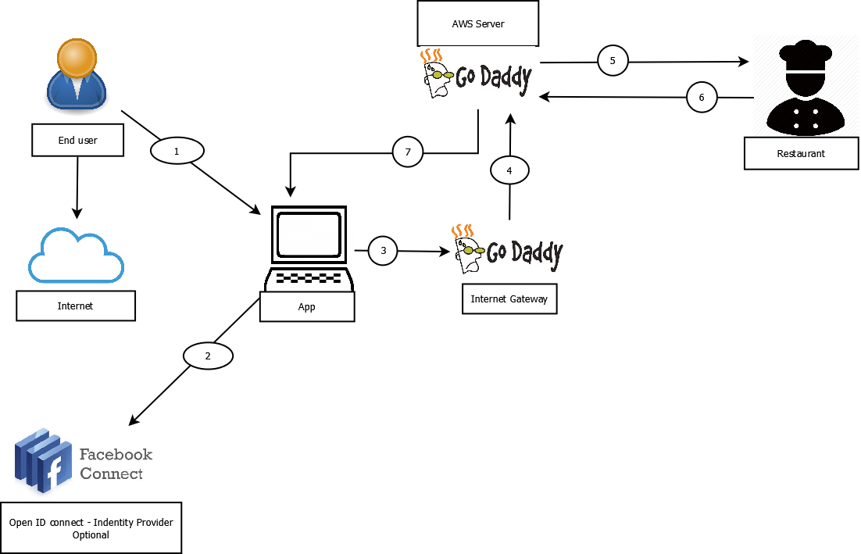

Description:

1 – End user starts using the Application

2- End user needs to either log onto RPR Booking application by creating a new account through the application or log in using their Facebook profile.

The information is run by the Facebook API, once the identity is confirmed the user is connected to the application.

3 – App connect through GoDaddy, where the application is being hosted.

4 – Information is sent to AWS server as GoDaddy uses AWS servers/

5 – Information is then sent out to the restaurant where it checks for availability.

6 - Whether the restaurant has availability or not, information will still be sent back to the End User.

7 – The booking information is then sent back to the end user, displayed through the application.

1. We are providing a web application which can be accessed through any device.
2. There is no need for any installation on the end user device.
3. End users must be connected to the internt.

References

* Jesse James Garrett’s The Elements of User Experience: User-Centered Design for the Web and Beyond (2nd Edition).